**Task 2 for submission**

**Part A**

*This task addresses* ***Unit Objective 2 – Apply accounting principles and processes relating to accounting and end-of-month reporting for a service business.***

Lesley Petersen began her business, Petersen’s Consultancy Service on 1 July 2018.

Apply accounting principles to analyse the following transactions by completing a transaction analysis table.

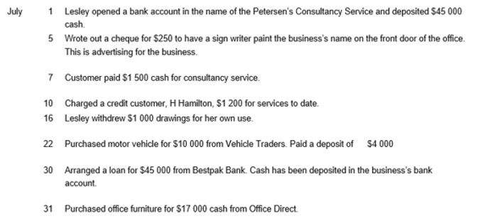

**Part B**

*This task addresses* ***Unit Objective 1 - Comprehend accounting concepts, principles and processes relating to accounting and end-of-month reporting for a service business.*** *The cognitive verbs,* ***describe*** *and* ***explain*** *are components of* ***comprehend*** *ie to show your comprehension of a concept, principle or process, you must describe or explain the concept, principle or process.*

In 50 – 75 word paragraphs, **describe** the following accounting concepts, principles or processes:

1. Transaction analysis

Transaction analysis is when you look at transactions that have occurred and analyse the accounting impact of these transactions. This will involve categorising the transactions as A, L, OE, R, or E and identifying their nature as Dr or Cr. Analysis can be done using an analysis table that takes you through the steps taken to conclude whether a Dr or Cr needs to be recorded.

1. Double entry

Double entry is an accounting recording system in which every debit entry has a corresponding credit entry. All transactions must involve at least two accounts. Total debits must equal total credits in every transaction.

1. Source documents which evidence cash and credit transactions

Source documents are generated when a business transaction occurs and are used by the business to provide evidence that the transaction has occurred and verifies the details of the transaction. The source documents are also used to collect data which is entered into the accounting system. Examples of source documents include receipts, cash register dockets, cheque butts, invoices, memos, bank statements and journal vouchers.

1. General journal

A journal is used to organise the information from source documents and forms the basis of double entry accounting. The general journal is a book of original entry in the accounting process, records information obtained from source documents and records transactions in their debit and credit components.

In a 50 – 75 word paragraph, **explain** how debits and credits are deduced for increases/decreases in the elements of the accounting equation.

The accounting equation is composed of Assests. Liabilities and Owner’s Equity. Revenues and Expenses also have an effect on owner’s equity, as profits will increase the owner’s equity while losses decrease the owner’s equity.

Each component (A, L, OE, R & E) has a nature, which is either debit or credit. If the transaction that occurs has the effect of increasing the account, the account is treated the same as its nature. If a transaction has the effect of decreasing the account, the account is treated opposite to its nature.